**EPSA TEAM - CAR N°81**

**REAL CASE**

**SUSPENSIONS AND SHOCKS**

Objective: 20% cost reduction – consequences on performance

Assemblies concerned with cost reduction:

|  |  |  |  |
| --- | --- | --- | --- |
| Front suspension  (SU A0500) | Rear suspension  (SU A0700) | Rear tierod  (SU A0900) | Front pullrod  (SU A1200) |
|  |  |  |  |

|  |  |
| --- | --- |
| Initial cost of Suspensions and Shocks | $ 2817.33 |
| Final cost of Suspensions and Shocks | $ 2261.03 |
| **Reduction percentage** | **19.75 %** |

The 20% cost reduction target is almost achieved, with a slight increase of mass and a loss of adjustment during testing, with minor impact on vehicle dynamic. In order to achieve this, we have to modify:

* the dampers
* the rods, from carbon parts to steel parts.

It will reduce the performance of the car but in a reasonnable way, not leading in a massive decrease of global performances.

**FRONT & REAR SUSPENSIONS**

1. Utilisation of another damper

|  |  |  |  |  |
| --- | --- | --- | --- | --- |
| Initial solution | Final solution | Initial cost of the assemblies | Final cost of the assemblies | Saving of the assemblies |
| Damper Öhlins TTX25 MkII | Damper, Risse Jupiter 5 | $ 1359.13 | $ 839.13 | Material: $ 520 |
| TOTAL |  |  |  | **$ 520** |

**FRONT PULLROD & REAR TIEROD**

1. Utilisation of a steel design instead of a carbon design

|  |  |  |  |  |
| --- | --- | --- | --- | --- |
| Initial solution | Final solution | Initial cost of the assemblies | Final cost of the assemblies | Saving of the assemblies |
| Carbon front pullrod, aluminium inserts assembled by glue | Steel front pullrod, steel inserts assembled by welding | $ 46,96 | $ 34,21 | Parts: $ 17,92  Material: + $ 0,54  Process: $ 0,46  Tooling: + $ 1,34 |
| Carbon rear tierod, aluminium inserts assembled by glue | Steel rear tierod, steel inserts assembled by welding | $ 56,99 | $ 37,20 | Parts: $ 19.24  Material: + $ 0,46  Process: $ 2,36  Tooling: + $ 1,34 |
| TOTAL |  |  |  | **$ 36,30** |

**ASSEMBLIES – FRONT AND REAR SUSPENSIONS**

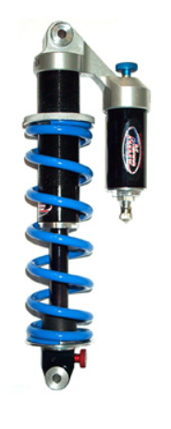**Idea**

Utilisation of another model of damper, the Jupiter 5, Risse.

**Effect on performance**

* The travel and packaging are identical than the previous solution.
* Utilisation of the same type of damper: monotube with compression piston and piggyback
* Passage from four to two settings:
* Originally, two settings for compression and rebound for high speed and two settings for compression and rebound for low speed
* On the Jupiter 5, only two settings for compression and rebound with no differentiation between high speed and low speed

High speed concern high frequency bumps such as for instance a rough section of pavement or many little successive defects on the road. Such settings can be useful during testing because the car can roll on an imperfect coating, which could have limited but unwanted effects on the dynamic of the vehicle. However, during the competition, the coating is close to perfect and such settings aren’t necessary to ensure the best possible behaviour for the car.

**Cost table**

*The total amount of these assemblies is decreased by 38 %, from 1359.13 $ to 859.13 $. Two adjustment options are lost, but these adjustments are not very useful in a FSAE competition, because of the very nice quality of the road track.*

**FRONT SUSPENSION**

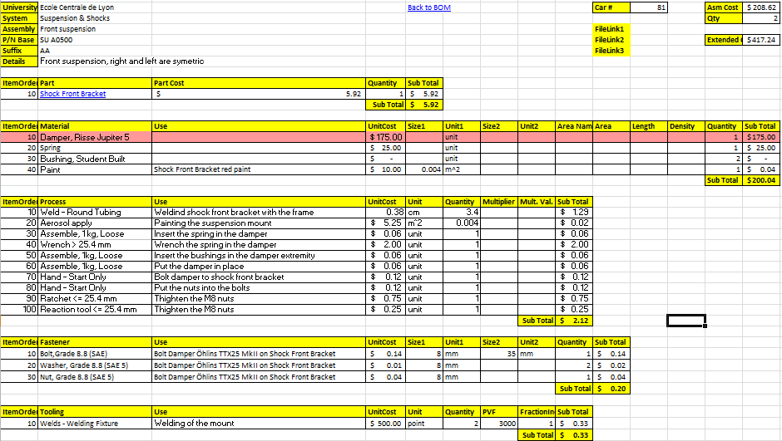

**REAR SUSPENSION**

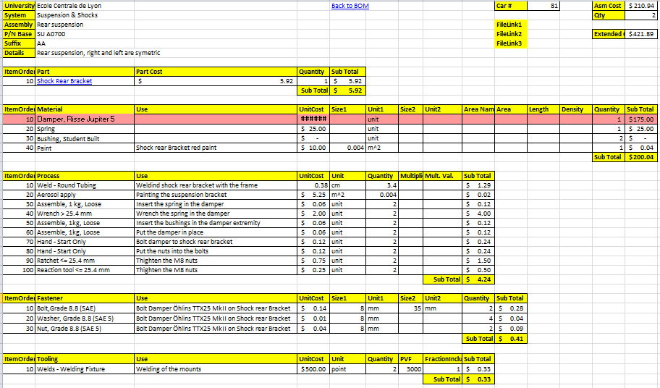

**ASSEMBLIES – FRONT PULLROD AND REAR TIEROD**

**Idea**

Changing the carbon design to a steel design. Inserts are now in steel instead of aluminium. Assembly of the tube into the inserts is now made my welding instead of glue.

**Effect on performance**

**Mass**

The new parts are about 400 grams heavier. These parts are suspended, so the impact is bigger on the dynamic behaviour of the car.

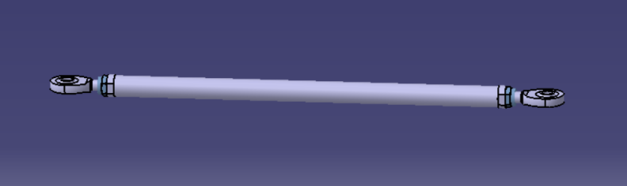

**Manufacturing**

tba

**Part quality**

The rear pushrod are already in steel.

**Cost table**

*The total amount of these assemblies is decreased by 31 %, from 103.95 $ to 71.41 $. The dynamic behaviour of the car is now less good, because the suspended mass is higher.*

**FRONT PULLROD**

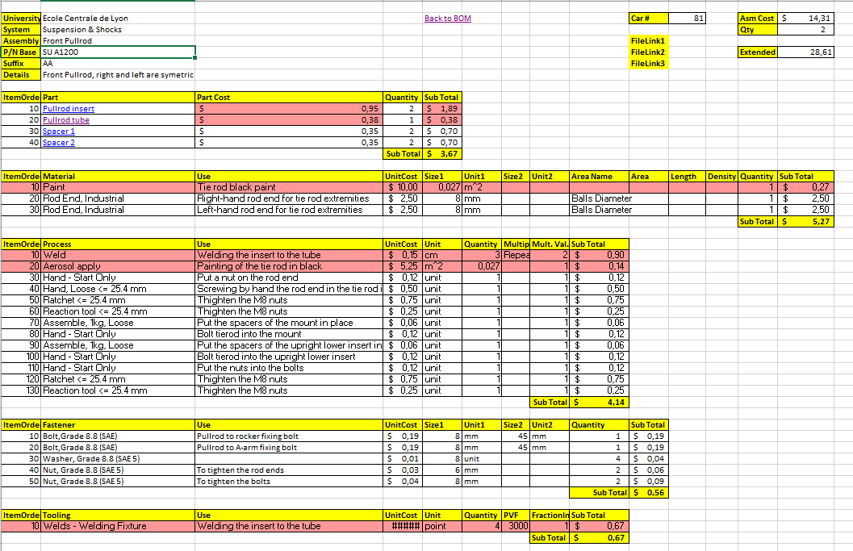

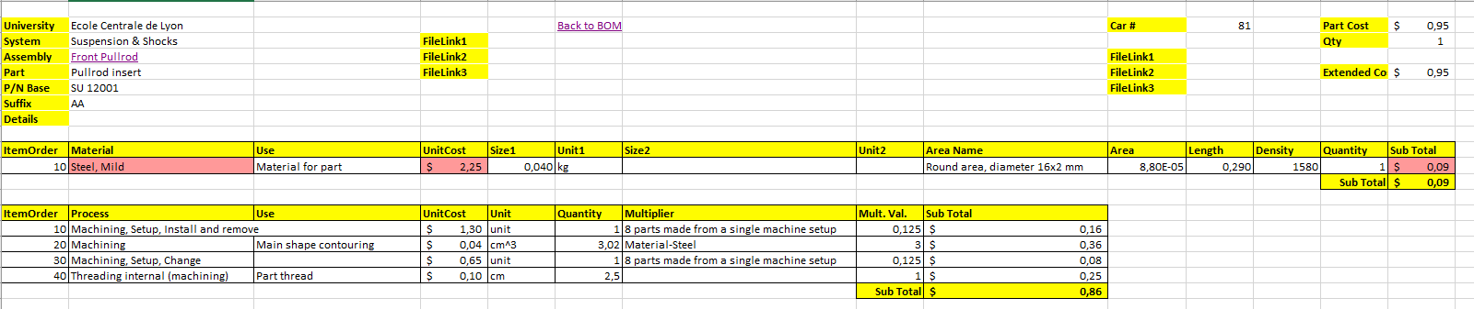

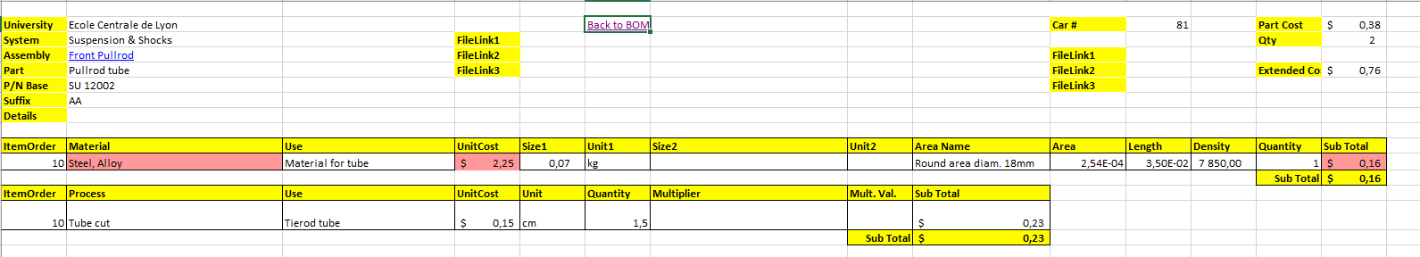

**REAR TIEROD**

